Circuit Analysis (Lab # 2)
Experiment 2: Measurements of Waveforms and Fundamental Quantities, Basic resistive circuits.

Name: Shahroz Ahmad Registration No: 2025_CE_115 Date: 11-03-2026 Grade and Signature: ………………………
CLO3 | Make measurements in their own constructed electric circuits.
Psychomotor/Affective | Level1 (1) | Level2 (2-3) | Level3 (4-5) | Level4 (6-7)
Report Marks (3) |  |  | Total marks (10)

_
Objectives: This experiment will provide exposure to measurements of waveforms and Fundamental Quantities, Basic resistive circuits. A primary purpose of this lab course is for you to master the use of electronic test equipment and measurement of fundamental quantities.
Equipment required:
Power Supply, Breadboard, Oscilloscope, Signal Generator Connecting wires, Resistances, Multimeter.
Procedure

Experiment # 1

SIGNAL GENERATOR AND OSCILLOSCOPE
- Use the signal generator and the oscilloscope to perform the following tasks.
- Build circuit ‘A’ shown below in Figure 1.
- Set the signal generator to generate a sinusoidal signal with a frequency of 100 Hz and peak-to peak voltage of 5V.
- Set up one probe across input signal, and another across R1 and R2 alternatively.
- Measure and draw all the voltages and time related parameters on the graphs below.
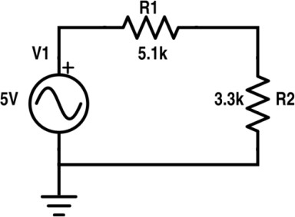
Figure 1 Circuit ‘A’

Resistor | Input voltage | RMS Voltage | P-P Voltage
R1 | 5V | 1.07V | 3.04V
R2 | 5V | 0.70V | 1.96V
One horizontal box = 10ms One horizontal box = 10ms
One vertical box = 0.5V One vertical box = 0.5V
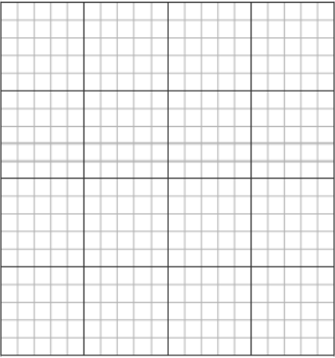

Input Voltage = 5V Voltage R1 = 3V

Figure 2 Input Voltage Signal Figure 3 Voltage Signal across R1

One horizontal box = 10ms One horizontal box = 10ms
One vertical box = 0.5V One vertical box = 0.5V Voltage R2 = 2V Voltage = 7V




Figure 5 Voltage Signal across R2 Figure 6 Draw 7V Sinusoidal

Experiment # 2

SIGNAL GENERATOR AND OSCILLOSCOPE
- Use the signal generator and the oscilloscope to perform the following tasks.
- Build circuit ‘B’ shown below in Figure 7.
- Set the signal generator to generate a sinusoidal signal with a frequency of 200 Hz and peak-to peak voltage of 7V.
- Set up one probe across input signal, and another across R1, R2 and R3 alternatively.
- Measure and draw all the voltages and time related parameters on the graphs below.
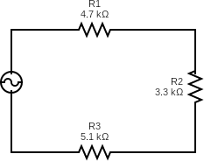
Figure 7 Circuit ‘B’

Resistor | Input voltage | RMS Voltage | P-P Voltage
R1 | 7V | 0.89V | 2.51V
R2 | 7V | 0.62V | 1.76V
R3 | 7V | 0.97V | 2.73V
R1 and R2 | 7V | 1.51V | 4.27V
R2 and R3 | 7V | 1.59V | 4.49V
One horizontal box = 20ms One horizontal box = 20ms
One vertical box = 0.7V One vertical box = 0.7V
Input Voltage = 7V Voltage R1 = 2.5V



Figure 8 Input Voltage Signal Figure 9 Voltage Signal across R1

One horizontal box = 20ms One horizontal box = 20ms
One vertical box = 0.7V One vertical box = 0.7V
Voltage R2 = 1.8V Voltage R3 = 2.7V



Figure 10 Voltage Signal across R2 Figure 11 Voltage Signal across R3

One horizontal box = 20ms One horizontal box = 20ms
One vertical box = 0.7V One vertical box = 0.7V
Voltage across R1 and R2 = 4.3V Voltage across R2 and R3 = 4.5V



Figure 12 Voltage Signal across R1 and R2 Figure 13 Voltage Signal across R2 and R3

- Define Ohm’s law.
Ohm’s Law states that the current flowing through a conductor is directly proportional to the voltage across it, provided the temperature remains constant.
Post Lab Questions

- What is resistor?
A resistor is an electronic component that limits or controls the flow of electric current in a circuit.

- How resistor works?
A resistor works by opposing or limiting the flow of electric current in a circuit.

- What is your inference from the input and output waveforms on oscilloscope?
The output waveform follows the same sinusoidal shape as the input waveform, but its amplitude (voltage) may change depending on the circuit components such as resistors. This shows that the circuit affects the magnitude of the signal while keeping the same frequency and waveform shape.

- Show calculations of 7V input signal (Figure 10) from signal generator.
  - Voltage calculations (Following volt/dev and number of boxes of oscilloscope)
  - Frequency/Period calculations (Following Steps in frequency measurements section)
  - Current calculation (Ohm Law)

- Voltage Calculation:
V2=R2/R1+R2+R3 * Input Voltage
V2=3.3/13.1 * 7
V2=1.8V
- Frequency Calculation:
F=200Hz
T=1/F
T=1/200
T=5ms
- Current Calculation:
I=V/R
I=1.8/13100
I=0.00014 A

